12th Feb 2024 | SSE Renewables  200 Dunkeld Road  Perth  PH1 3AQ
Work by SSE Renewables in your area
We would like to make you aware of works starting shortly in your area.
This week we have commenced development works for the eventual construction of a Solar Farm on land shown on the enclosed map to the west of Foston. As part of the works, we will also be commencing development of a new Point of Connection (POC) on Ease Lane to the east of Westborough (at the top of the enclosed map) and laying cables along a route between the two locations. This infrastructure will allow the energy from the site to be delivered into the electricity network. These works were approved by South Kesteven District Council, planning permissions S20/1433 and S21/2461.
A copy of this letter has been delivered to postal addresses close to both locations.
Why are we doing this?
Solar energy is an efficient source of renewable energy, and this site is expected to have a generating capacity of up to 49.9MW – this is enough clean, renewable power for over 15,000 homes, and substantial CO2 saving of 21,500 tonnes of CO2 per annum, making a meaningful contribution to meeting the UK’s greenhouse gas emission targets. It will also help us to meet the growing demand for electricity both now and into the future.
The project was granted permission in 2021 and SSE purchased the right to develop the site from Stark Energy. The planning permission is for 40 years, after which we must return the site to its original condition.
What should you expect to see happening?
We have appointed a company called JJMac to lead on the commencement of development works at both locations. Starting in February our contractors will be carrying out works including;
- general clearing of both sites
- installing new gates and fencing
- provision of welfare facilities for workers
- creating a new site access road at the Solar Site
- constructing a new junction into the POC site off Ease Lane
We will keep you updated as things progress, so you know how we are doing and what to expect next.
How much traffic will there be coming and going to the site?
In line with the approved traffic management plan; at the peak of this stage of our activities, you could expect to see an average of around 8 Heavy Goods Vehicle deliveries to the main solar site and much less at the POC, but much of the time it will be quieter. Our contractors will be giving consideration to the route that traffic takes to the site and logistics planning to avoid multiple deliveries arriving at the same time.
We will ensure that the public roads are kept clear of any debris and dust to ensure roads are kept safe at all times.
When will we be working?
Work will be happening between 8am and 6pm from Monday to Friday – this includes deliveries. We may carry out some activities on a Saturday, this will be restricted to mornings and only where necessary.

We want to be a ‘good neighbour’ and will keep in touch with you and some of the organisations in the area as the project is delivered so you know how the work is progressing. We intend to abide by all the commitments made to communities through the planning process and look to give back something to the communities where we work in other ways.
If you have any questions for me, please do not hesitate to get in touch – charlotte.hewes@sse.com.

Yours sincerely,

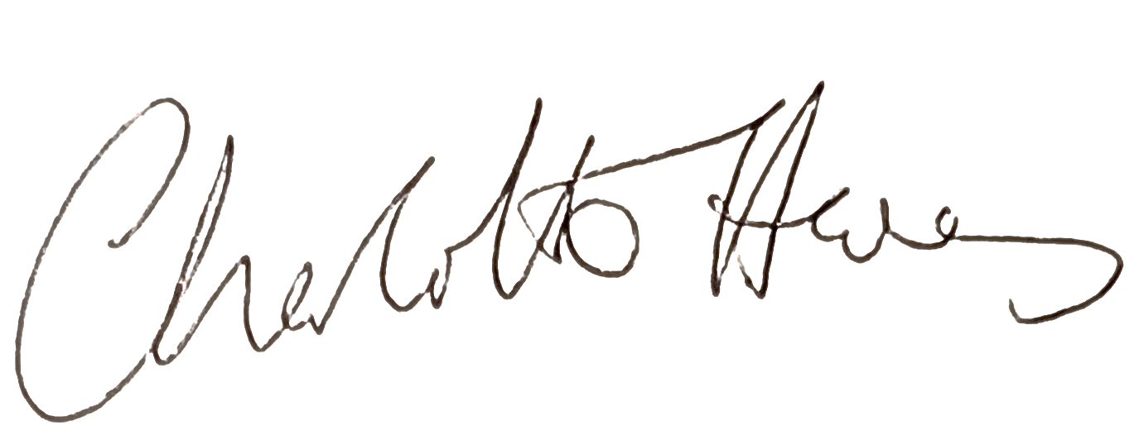

Charlotte Hewes
Stakeholder Engagement Manager

