Minutes of the Meeting of Foston Parish Council held on 5th May 2026 at 19:30 at Foston Village Hall.

Present: Cllr Christina Lees, Cllr John Munro, Cllr Tracey Gardner, Cllr Keith Spikings.
Cllr P Wood, Clerk to Council – C Smith.

Public Forum:

Update on Foston Village flower beds and boarders from Janet Bray. In the absence of Janet Bray the clerk gave an update on the progress of the care and maintenance of the flower beds around the village that were damaged by contractors. LCC have met with Mrs Bray and they have decided that they will help with the Newark Hill site but have held back on the A1 site as it will incur great financial cost in closing the slip road and diverting traffic. It was suggested that the Adventure Scouts could be enlisted to help. Mrs Bray is sourcing the materials for the flower beds and will revert back to council.

Resident Mr Douglas Smith was present.

Council Session started at 19.30

26054. To elect a Chairman of Council for 2026/2027 – Let it be minuted that Cllr Leitchfield stood down as chair and councillor as of 10th April.
Resignation was accepted by Council Unanimous

26055. To receive the Declaration of Acceptance of Office of Chairman of Foston Parish Council - Following election Cllr Lees signed the appropriate declaration of acceptance of office as an interim position.
Unanimous
26056. Apologies and reasons for absence (To receive and resolve reasons for absence in accordance with the requirement of the Local Government Act 1972)
None. Unanimous

26057. Declarations of Interests: To receive declarations of interest in accordance with the requirements of the Localism Act 2011 and consider any applications for dispensations in relation to disclosable pecuniary interests or personal interests.
None. Unanimous

26058. To receive and approve the minutes of the Parish Council meeting held on 3rd March 2026
It was Resolved: that the minutes of the Parish Council meeting held on the 3rd March 2026 be approved and signed by the Chairman as a correct record. Unanimous

26059. To consider applications to fill the Parish Council vacancy by co-option.
No applicants

26060. To receive and consider reports from County and District Councillors’
Cllr Paul Wood commenced with a report on the collection of the food waste material which, reportedly, is going well with only a few concerns. The local government reorganisation consultation period has now ended with elections on 27th May for new authorities in Lincolnshire. In June/July 2026 there will be announcements as to the new councils and how they will be divided. These divisions will be put into place in April 2028

26061. To elect a Vice Chairman of Council for 2026/2027
Carried forward to the meeting to be held in July 2026

26062. To consider the report of the Internal Auditor for the financial year ended 31st March 2026.
It was - Resolved: - that the report of the Internal Auditor, Mr Patrick Traynor, for the financial year ended 31st March 2026 following review be accepted by Council. No action required on the report. Unanimous

26063. To consider Parish Council Accounts for the financial year ended 31st March 2026 – It was
Resolved: that the Accounts for the financial year ended 31st March 2026, be approved, accepted, and signed by the Chairman. Unanimous

26064. To consider approval of the 2025/2026 Annual Return Certificate of Exemption - It was
Resolved: that the Annual Return Certificate of Exemption of the Annual Return for the financial year ended 31st March 2026, be approved, accepted, and signed by the Chairman. Unanimous

26065. To consider approval of the 2025/2026 Annual Return – Annual Governance Statement - It was
Resolved: that the Annual Governance Statement of the Annual Return for the financial year ended 31st March 2026, be approved, accepted, and signed by the Chairman. Unanimous.

26066. To consider approval of the 2025/2026 Annual Return – Accounting Statements - It was
Resolved: that the Accounting Statement of the Annual Return for the financial year ended 31st March 2026, be approved, accepted, and signed by the Chairman. Unanimous

26067. To consider and review Foston Parish Council Standing Orders – It was Resolved: that the Foston Parish Council Standing Orders be reviewed at the July 2026 meeting. Unanimous

26068. To consider and review of Foston Parish Council Financial Regulations - It was
Resolved: that the Foston Parish Council Financial Regulations be reviewed at the July 2026 meeting. Unanimous
26069. To consider and review Foston Parish Council Risk Register - It was
Resolved: that further review of the risk register be undertaken at the July 2026 meeting to resolve any required actions. Unanimous

26070. To consider and review inventory of land and other assets - It was.
Resolved: that the review of the asset register would be reviewed and updated for the next council meeting in July 2026 Unanimous

26071. To review and confirm arrangements for insurance cover in respect of all insurable risks. Resolved: following a review of the insurance cover the policy will remain with Ansvar Insurance via CAS Ltd. For a further three years at a fixed price. Unanimous

26072. To consider and confirm arrangements for the review of:

  - Council Complaints Procedure - It was. Resolved: that Council Complaints Procedure would remain the same, no change. Unanimous

  - Councillor Co-Option Policy – It was. Resolved: that a review of the Councillor Co-Option Policy would remain the same, no change Unanimous

  - Training and Development Policy - It was. Resolved: that a review of the Training and Development Policy should include a refresher course every 3 years for Councillors. Clause to be added. Unanimous

  - Council’s policies, procedures, and practices in respect of its obligations under freedom of information and data protection legislation - It was. Resolved: that a review would take place in July.
Unanimous
  - Council’s policy for dealing with the press/media - It was. Resolved: that a review of Media Policy v 1.0 would take place in July. Unanimous

  - Council’s employment policies and procedures. - It was Resolved: that a review would take place. Unanimous
  - Council’s expenditure incurred under s.137 of the Local Government Act 1972 - It was.
Resolved: that the report from the clerk detailing expenditure incurred under s.137 of the Local Government Act 1972 was accepted. Unanimous

  - Council’s policy for the awarding of grants - it was Resolved with two abstains and three for’s due to declarations of interest: that the review of the grant awarding policy was complete with one amendment. Unanimous
26073. To resolve to appoint an Internal Auditor for Foston Parish Council for 2026/2027. It was
Resolved: that Mr P Traynor be appointed Internal Auditor for 2026/2027. Unanimous.

26074. To resolve to appoint Parish Council representatives / roles for 2026/2027- It was Resolved: That Council make the following appointments for 2026/2027 Unanimous.

Neighbourhood Watch (Cllr Lees) | Playing Field – (Cllr Munro)
Village Hall (Cllr Fellows) | Police – (Cllr Lees)
Foston Neighbours (Cllr Lees) | Foston Conservation Group (Cllr Munro)
Roads and Footpaths (Cllr Lees) | Speed Indicator Device Co-ordination- – (Clerk to Council)
Planning (Cllr Gardner) | Facebook / Social Media – (Clerk to Council)
Emergency Plan - (N/A) | Community Hub - (Cllr Spikings)

26075. To review and consider Council subscriptions to other bodies. - It was Resolved: that the Council renew subscriptions to LALC, LCR, SLCC and ICO for 2026/2027 Unanimous.

26076. To consider and approve the timetable of meetings for the 2025/2026 administration period. It was Resolved: that ordinary meetings of Council are held Bi-monthly on the 1st Tuesday – 7th July 2026, 1st September 2026, 4th November 2026, 5th January 2027, 2nd March 2027, 4th May 2027.
Annual Parish Meeting 27th May 2026 Unanimous

26077. To consider an update on Goosegate Lane Flooding, LCC Highways plans and resolve on any action to be taken. It was resolved that Cllr Gardner will contact Michelle Joseph for an update on the clearance of the drain. It was confirmed that the national highways are waiting for Anglian Water to complete their work first.

26078. To consider dog fouling and resolve on any action to be taken. It was resolved that the council clerk will communicate with SKDC to obtain new dog fouling signs to be erected around the village. The cleanliness of the dog bins has been reverted to the next meeting in July 2026 Unanimous

26079. To consider Councillor training and resolve on any action to be taken. It was resolved that all councillors should embark on refresher courses through LALC Unanimous

26080. To receive an update relating to permissive access rights to Foston Playing Field and resolve on any action to be taken. Cllr Spikings gave an update on the permissive access to the playing field and confirmed that the solicitors have now devised a letter and sent it to the resident who have been given a timeline to reply.

26081. To consider speed indicator devices and resolve on any action to be taken. It was resolved that Cllr Lees, Cllr Spikings and the Clerk should attend the speed indicators to download the statistics recorded.
Unanimous
26082. To confirm the date of the Annual Parish Meeting as being 27th May 2027
It was confirmed as such with times set at 19.00 – 21.30 Unanimous

26083. To consider and receive an update on matters relating to Gorrie Hall, community hub report, future direction and resolve on any action to be taken.
Cllr Spikings has circulated his report and the conclusion of this is that it would be more financially viable to invest in what property we have rather than rebuild. The Hub would not be sustainable enough to warrant the financial outlay. It was noted that the trustees of the Village Hall and Gorrie Hall are happy with this decision and the content of the report. A synopsis of the report will be forwarded to the village via email and paper format. Thanks was given to Cllr Spikings for all his hard work in the production of this report.
Unanimous
26084. To consider and receive an update on the lease for 1st Foston Scout Group and resolve on any action to be taken. Cllr Spikings gave his report revealing that the lease has nearly been completed. Cllr Spikings will communicate with Chattertons solicitors in regards the strip of land outside the scout hut and is very confident that registry of the land will be passed.

26085. To consider and review the handover from the chair to the clerk and Cllr Lees and resolve on any action to be taken. It was resolved that following the resignation of the chair there should be an additional authority to counter agree bank payments. Cllr Spikings and Cllr Gardner have agreed to be put forward.
Unanimous
26086. To consider the finalisation of the probation period of the clerk. It was resolved that the chair has passed the probation period and will remain the clerk of Foston Parish Council. Unanimous

26087. To consider and resolve the chairperson at each meeting. It was resolved that until a new chair has been elected the councillor’s will take it in turns to head the bi-monthly meetings. Cllr Lees will head the July meeting with Cllr Spikings in September and Cllr Gardner in November. Cllr Lees will also head the Annual Parish Meeting. Unanimous

26088. To receive and consider a report from Cllr Gardner on Planning Matters

Ref: S26/0146: Date Received 28th January 2026: Applicant - Mr and Mrs Andrew and Flo Gilmour Proposal - Demolition of existing bungalow and construction of new dwelling.
Location - Ellensdale Back Lane Foston Lincolnshire NG32 2LA
Decision/Date 25th March 2026: permission has been refused

Ref: S26/0536: Date Received 23 Mar 2026: Location - 4 Newark Hill Foston Lincolnshire NG32 2LF
Proposal - Ground floor side extension to dwelling
Decision - Awaiting decision

Ref: S26/0343 Date Received 25 Feb 2026 Location - Highfield Farm Poultry Unit Fallow Lane
FostonProposal - Erection of a self-build agricultural workers dwelling
Decision - Awaiting decision

26088. To consider Financial Matters

- To receive the Clerks report on payments between meetings.
Resolved: That Council approve payment of the following items Unanimous

Financial Year 2026/2027

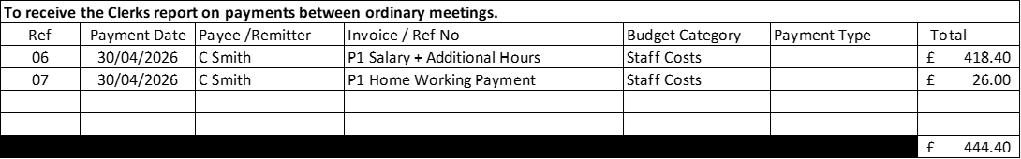

- To review and consider accounts for payment
Resolved: That Council approve payment of the following items Unanimous

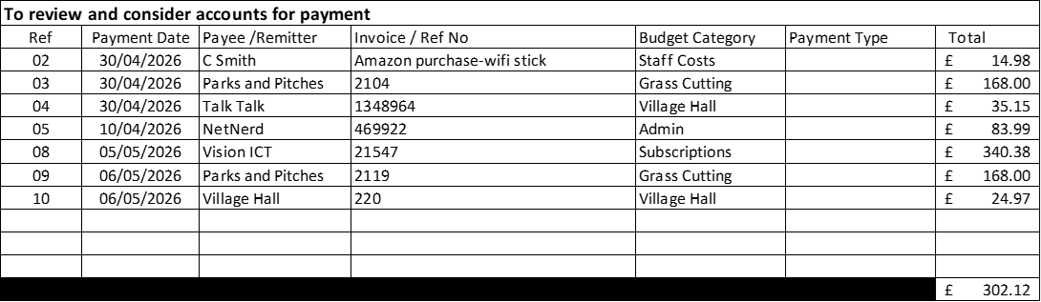

- To review income and expenditure to 31st March 2026 – Income and expenditure to 31st March 2026 was reviewed and noted, no further action.

- To review income and expenditure to 30th April 2026 – Income and expenditure to 30th April 2026 was reviewed and noted, no further action.

- To review bank account reconciliations to 31st March 2026 - It was resolved: that the bank account reconciliation for 31st March 2026 be accepted and approved. Unanimous

- To review bank account reconciliations to 5th April 2026 - It was resolved: that the bank account reconciliation for 5th April 2026 be accepted and approved. Unanimous

26089. To consider items for inclusion on the agenda for the next Parish Council Meeting Tuesday 7th July 2026 at 7.30pm To include the purchase of a new village remembrance bench and the possibility of the purchase of a new laptop for the clerk. Unanimous

C Smith

C Smith Clerk to Council - Foston Parish Council 25/05/2026

