Councillor Ken Bamford
Hough Division
Lincolnshire County Council
County Offices
Newland
Lincoln LN1 1YL
Email: cllrk.bamford@lincolnshire.gov.uk

Dear fellow councillors,

Hough Councillor Report - March 2026

I am continuing to work with LCC to try and progress ongoing broader issues such as speeding, parking, roads and drainage (flooding), which are recurring themes across Hough.

In particular on roads, we are starting to look at how repairs are categorised and prioritised, and the quality of the repair itself, with more robust solutions, rather than fill patching.

Local Government Reorganisation (LGR): Our proposal was submitted to the government at the end of November, along with other proposals from other Lincolnshire councils. A public consultation has now started on all the proposals and is expected to last for 7 weeks. Details of our proposal and the work to date is at www.lincolnshire.gov.uk/yourlincolnshire.

Local Updates

Nothing to update.

All new issues that are proposed for LCC intervention should be logged in the PC meeting minutes and shared with Cllr Bamford. They will then be updated on in this report at the next meeting.

Thank you for your selfless service and continued vigilance in our community, we need everyone’s eyes and ears to help ensure our area remains a safe and well cared for place to live.

Best regards,

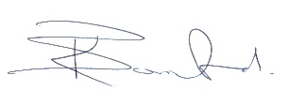

Councillor Ken Bamford
Hough Division

